**ES Lab 6 Report**

**INTERFACING LED TO ARM MICROCONTROLLER**

Date: 12th February, 2025

Phirozgar Irani

230905370

CSE 4B: B2

Q1. Write a C program to display an 8-bit binary up counter on the LEDs.

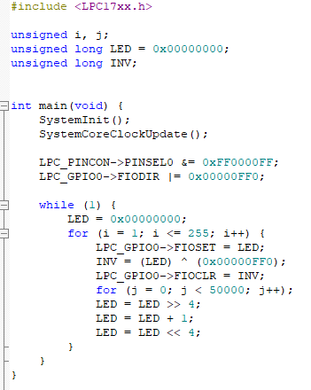

Q2. Write a C program to read a key and display an 8-bit up/down counter on the

LEDs.

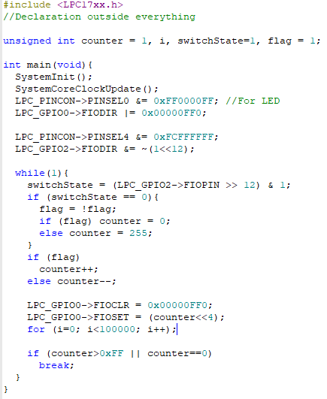

Q3. Write a program to simulate an 8- bit ring counter with key press (SW2).

